Example: Sam found how many **hours of sunshine** vs how many **ice creams** were sold at the shop from Monday to Friday:

|  |  |
| --- | --- |
| **"x" Hours of Sunshine** | **"y" Ice Creams Sold** |
| 2 | 4 |
| 3 | 5 |
| 5 | 7 |
| 7 | 10 |
| 9 | 15 |

Let us find the best **m** (slope) and **b** (y-intercept) that suits that data

y = mx + b

**Step 1**: For each (x,y) calculate x2 and xy:

|  |  |  |  |
| --- | --- | --- | --- |
| **x** | **y** | **x2** | **xy** |
| 2 | 4 | 4 | 8 |
| 3 | 5 | 9 | 15 |
| 5 | 7 | 25 | 35 |
| 7 | 10 | 49 | 70 |
| 9 | 15 | 81 | 135 |

**Step 2**: Sum x, y, x2 and xy (gives us Σx, Σy, Σx2 and Σxy):

|  |  |  |  |
| --- | --- | --- | --- |
| **x** | **y** | **x2** | **xy** |
| 2 | 4 | 4 | 8 |
| 3 | 5 | 9 | 15 |
| 5 | 7 | 25 | 35 |
| 7 | 10 | 49 | 70 |
| 9 | 15 | 81 | 135 |
| **Σx: 26** | **Σy: 41** | **Σx2: 168** | **Σxy: 263** |

Also **N** (number of data values) = **5**

**Step 3**: Calculate Slope **m**:

**m** = *(NΣxy − Σx Σy)***N(Σx2) − (Σx)2**

= *(5 x 263 − 26 x 41)***5 x 168 − 262**

= *(1315 − 1066)***840 − 676**

= *249***164** = 1.5183...

**Step 4**: Calculate Intercept **b**:

**b** = *Σy − m(Σx)***N**

= *41 − 1.5183 x 26***5**

= 0.3049...

**Step 5**: Assemble the equation of a line:

y = mx + b

y = 1.518x + 0.305

Let's see how it works out:

|  |  |  |  |
| --- | --- | --- | --- |
| **x** | **y** | **y = 1.518x + 0.305** | **error** |
| 2 | 4 | 3.34 | −0.66 |
| 3 | 5 | 4.86 | −0.14 |
| 5 | 7 | 7.89 | 0.89 |
| 7 | 10 | 10.93 | 0.93 |
| 9 | 15 | 13.97 | −1.03 |

Here are the (x,y) points and the line **y = 1.518x + 0.305** on a graph:

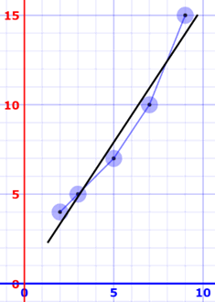

Nice fit!

Sam hears the weather forecast which says "we expect 8 hours of sun tomorrow", so he uses the above equation to estimate that he will sell

y = 1.518 x 8 + 0.305 = 12.45 Ice Creams

Sam makes fresh waffle cone mixture for 14 ice creams just in case

How does it work?

It works by making the total of the **square of the errors** as small as possible (that is why it is called "least squares"):

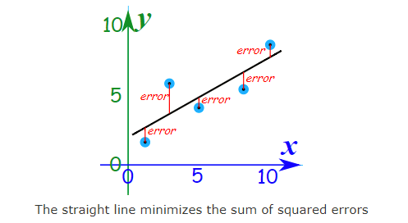  
The straight line minimizes the sum of squared errors

So, when we square each of those errors and add them all up, the total is as small as possible.

You can imagine each data point connected to a straight bar by springs:

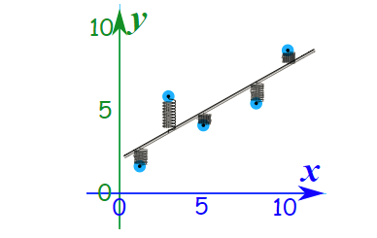

## Outliers

Be careful! Least squares is sensitive to [outliers](https://www.mathsisfun.com/data/outliers.html). A strange value will pull the line towards it

<https://faculty.elgin.edu/dkernler/statistics/ch03/index.html>